Taylor Cowley

220 Lab 01 Breadboard

April 28 2016

|  |  |  |  |  |
| --- | --- | --- | --- | --- |
| Cord | Low Bat | Temp | Fan | Alarm |
| 0 | 0 | 0 | 0 | 0 |
| 0 | 0 | 1 | 1 | 0 |
| 0 | 1 | 0 | 0 | 1 |
| 0 | 1 | 1 | 0 | 1 |
| 1 | 0 | 0 | 0 | 0 |
| 1 | 0 | 1 | 1 | 0 |
| 1 | 1 | 0 | 0 | 0 |
| 1 | 1 | 1 | 1 | 0 |

**Preparation**

Truth tables and equations:

Alarm = (low bat) * (cord)’

**G = B * A’**

Fan = (temp) * (((Low bat) * (cord)’)’ + (low bat)’)

Fan= temp * alarm’

**F = C * G’**

English:

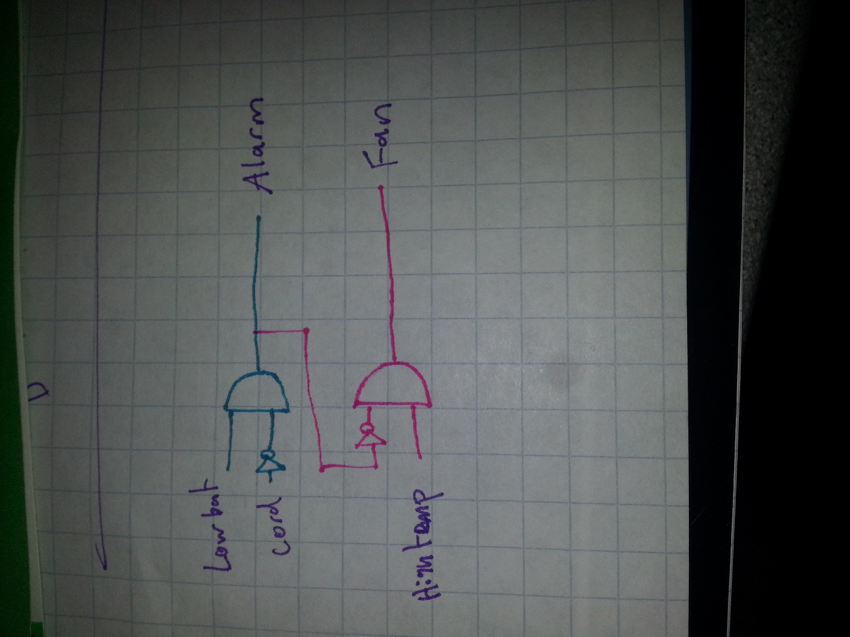The Alarm sounds when we have a low battery and are not

plugged in.

The Fan turns on when we have a high temperature and the

alarm is not sounding (high temperature and if low battery, has a cord)

Draw the schematic:

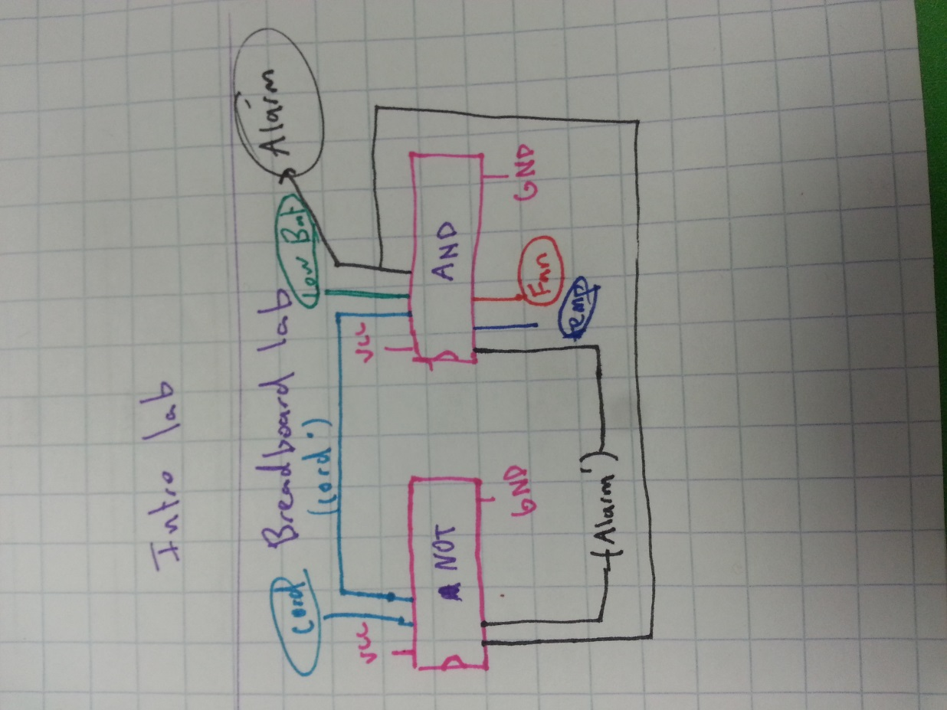**Procedure**

What I actually used:

Tested results of the circuit:

|  |  |  |  |  |
| --- | --- | --- | --- | --- |
| Cord | Low Bat | Temp | Fan | Alarm |
| 0 | 0 | 0 | 0 | 0 |
| 0 | 0 | 1 | 1 | 0 |
| 0 | 1 | 0 | 0 | 1 |
| 0 | 1 | 1 | 0 | 1 |
| 1 | 0 | 0 | 0 | 0 |
| 1 | 0 | 1 | 1 | 0 |
| 1 | 1 | 0 | 0 | 0 |
| 1 | 1 | 1 | 1 | 0 |

**Anomalies**

My only problem was that I mixed up my AND and NOT chips, so nothing was plugged in properly.